**WEEK 1- ASSIGNMENT**

**1. Power BI Overview:**

Power BI is a **business intelligence (BI) tool by Microsoft** that enables users to analyze and visualize data, derive insights, and share reports across teams or organizations. It provides an intuitive interface for data modeling, reporting, and visualization, making it ideal for turning raw data into actionable insights.

**2.ETL:**

ETL stands for **Extract, Transform, Load**, and it is a fundamental part of data preparation in Power BI:

* **Extract**: Import data from various sources, including Excel, databases, APIs, or cloud services.
* **Transform**: Clean and shape the data using Power Query, such as removing duplicates, filtering, and creating calculated columns.
* **Load**: Save the cleaned and processed data into the Power BI data model for visualization and analysis.

**3. Report View:**

* This is the primary interface in Power BI where **visualizations and reports are created**.
* You can drag and drop fields, add charts, graphs, slicers, and maps, and arrange them to create interactive dashboards.
* Reports in this view are designed to be visually appealing and customizable.

**4. Model View:**

* Used to **manage relationships** between tables in your dataset.
* You can define the connections between different tables (e.g., one-to-many or many-to-many relationships).
* This ensures the data model is structured properly for analysis, enabling seamless integration of fields in reports.

**5. Table View:**

* Displays the raw **tabular data** that has been loaded into Power BI.
* You can inspect individual columns, rows, and values to verify data quality.
* Useful for debugging or checking the processed data after transformations.

**6. Transform Data:**

* This functionality, accessed via Power Query, allows you to **clean and manipulate your data** before loading it into the data model.
* Common transformations include:
  + Removing null values or duplicates.
  + Splitting or merging columns.
  + Aggregating data (e.g., sum, average).
  + Applying conditional formatting or filtering specific rows.
* Power Query also supports advanced functionalities like creating custom formulas using M (Power Query's formula language).

**Step 1:** Load the Dataset using Get data option

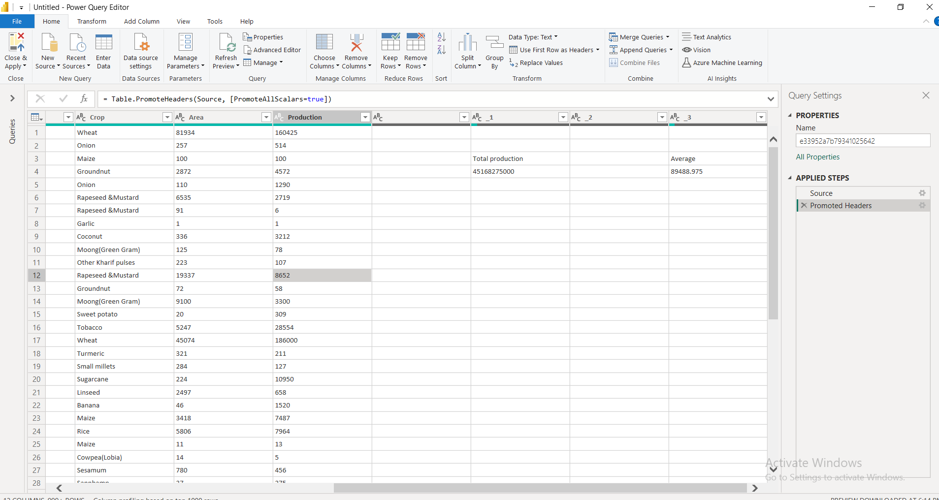

**Step 2:** Removing the unwanted columns:

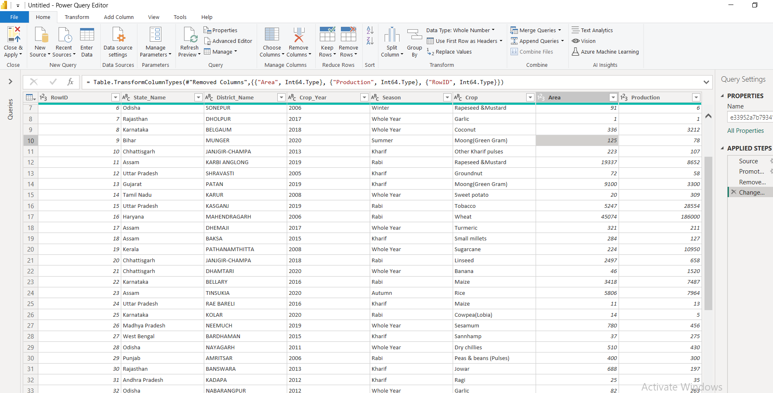

**Step 3:** Changing the datatype of the column

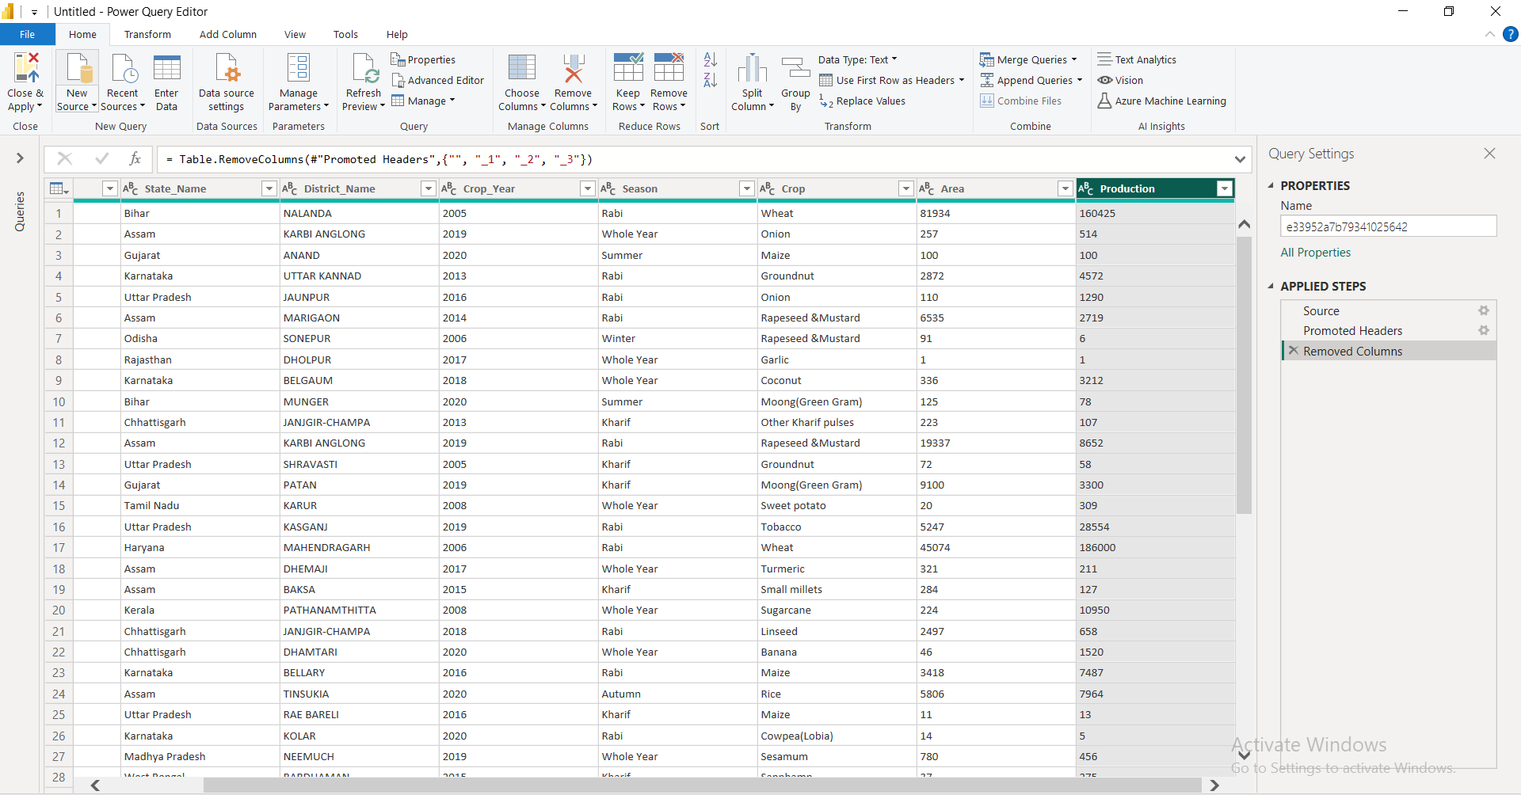

**Step 4:** checking the quality of the data or checking for any error:

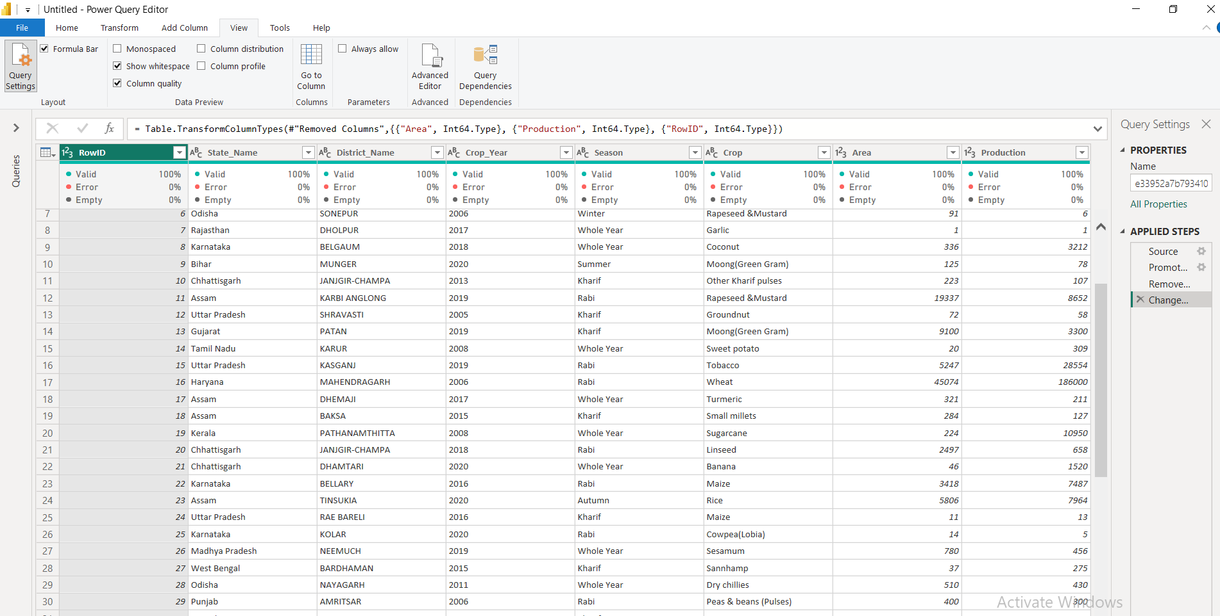

**Step 5:** Table view of the transformed Data

